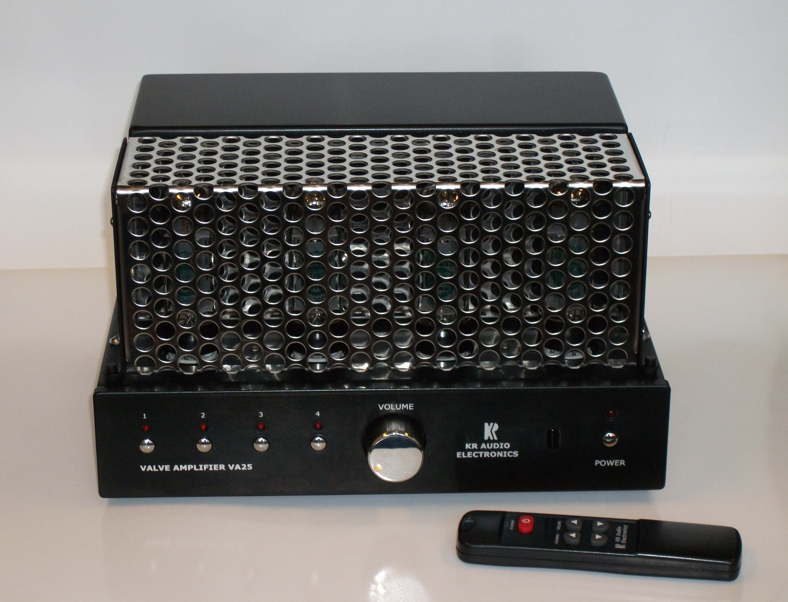

VA25

Stereo Integrated Amplifier

Technical Data

Power Tubes 4 x EL34

Output Stage Push-Pull Ultra-linear Class AB1
Output Power 2 x 25 W_{RMS} (THD=1%)
Output 8 Ω
Frequency Response 20Hz ÷20KHz (-1dB)
Feedback Zero
Driver Stage Depletion MOSFET class A
Preamplifier solid-state with mechanical (reed) relays
Remote Control volume & channel selector
Inputs 4 x line RCA (Cinch)
Input Sensitivity 0.75V_{RMS}/47kΩ (all channels)
Power requirements 230/115V_{AC}, 50/60 Hz
Power consumption 160VA
Operating temperature 5C° to 40C°
Weight Approx. 14Kg
Dimensions including projecting parts and controls (w/h/d)

Approx. 30 x 19 x 26 cm

